**SQL SERVER – Difference Between Union vs. Union All – Optimal Performance Comparison**

**UNION**  
The UNION command is used to select related information from two tables, much like the JOIN command. However, when using the UNION command all selected columns need to be of the same data type. With UNION, only distinct values are selected.

**UNION ALL**  
The UNION ALL command is equal to the UNION command, except that UNION ALL selects all values.

The difference between Union and Union all is that Union all will not eliminate duplicate rows, instead it just pulls all rows from all tables fitting your query specifics and combines them into a table.

***A UNION statement effectively does a SELECT DISTINCT on the results set. If you know that all the records returned are unique from your union, use UNION ALL instead, it gives faster results.***

Run following script in SQL Server Management Studio to see the result between UNION ALL and UNION. [**Download complete script from here.**](http://www.pinaldave.com/bimg/unionquery.zip)

/* Declare First Table */  
DECLARE @Table1 TABLE (ColDetail VARCHAR(10))  
INSERT INTO @Table1  
SELECT 'First'  
UNION ALL  
SELECT 'Second'  
UNION ALL  
SELECT 'Third'  
UNION ALL  
SELECT 'Fourth'  
UNION ALL  
SELECT 'Fifth'  
/* Declare Second Table */  
DECLARE @Table2 TABLE (ColDetail VARCHAR(10))  
INSERT INTO @Table2  
SELECT 'First'  
UNION ALL  
SELECT 'Third'  
UNION ALL  
SELECT 'Fifth'  
/* Check the data using SELECT */  
SELECT *  
FROM @Table1  
SELECT *  
FROM @Table2  
/* UNION ALL */  
SELECT *  
FROM @Table1  
UNION ALL  
SELECT *  
FROM @Table2  
/* UNION */  
SELECT *  
FROM @Table1  
UNION  
SELECT *  
FROM @Table2  
GO

In our example we have two tables: @Table1 and @Table2.

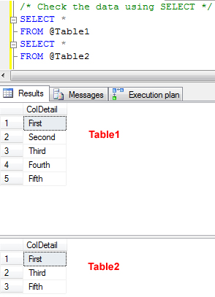

Now let us run UNION ALL and UNION together and see the resultset as well as Execution Plan compared to complete set of query. You can always turn on actual execution plan using CTRL+M.

We can see from the resultset of UNION ALL that it returns everything from both the table but from UNION it is very clear that only DISTINCT rows from both the table is only retrieved.

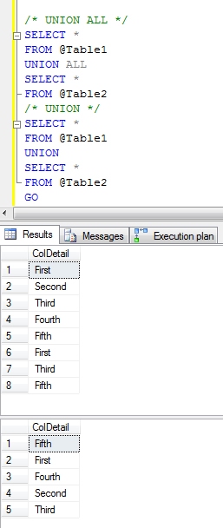

Additionally, when comparing the execution plan of UNION ALL and UNION it is also quite clear that UNION ALL is way less expensive than UNION as it does not have DISTINCT SORT operation.

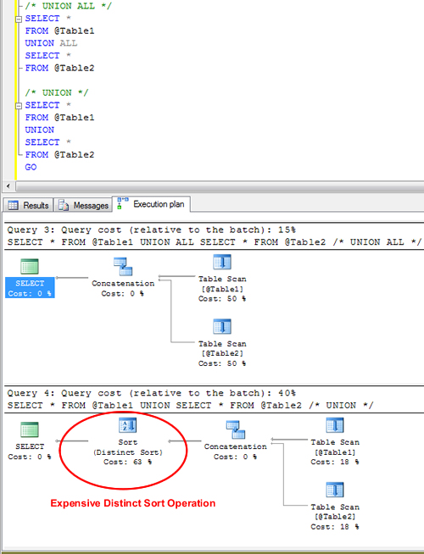

Let me know what do you think about this article. If you have any suggestion for improvement please let me know and I will update articles according to that.